S.D.M Society’s
SDM COLLEGE OF ENGINEERING AND TECHNOLOGY, DHAVALGIRI, DHARWAD -580002
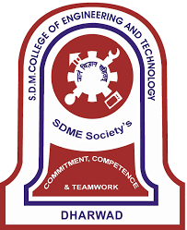
(An Autonomous institute affiliated to Visvesvaraya technological university)

DEPARTMENT OF INFORMATION SCIENCE AND ENGINEERING
5th semester B.E Academic Year 2025-26
MINOR PROJECT - I
COURSE CODE:22UISL505
“List Of Ideas for Minor Project – I”

Under the guidance of
“Prof. Varsha S Jadhav”

SUBMITTED BY
Sucheendra Bhat K S 2SD23IS051
Sharat C P 2SD23IS047
Prajwal S 2SD24IS404
Vaishnavi V Vaskar 2SD24IS406

5th Semester B.E Academic Year 2025-26

